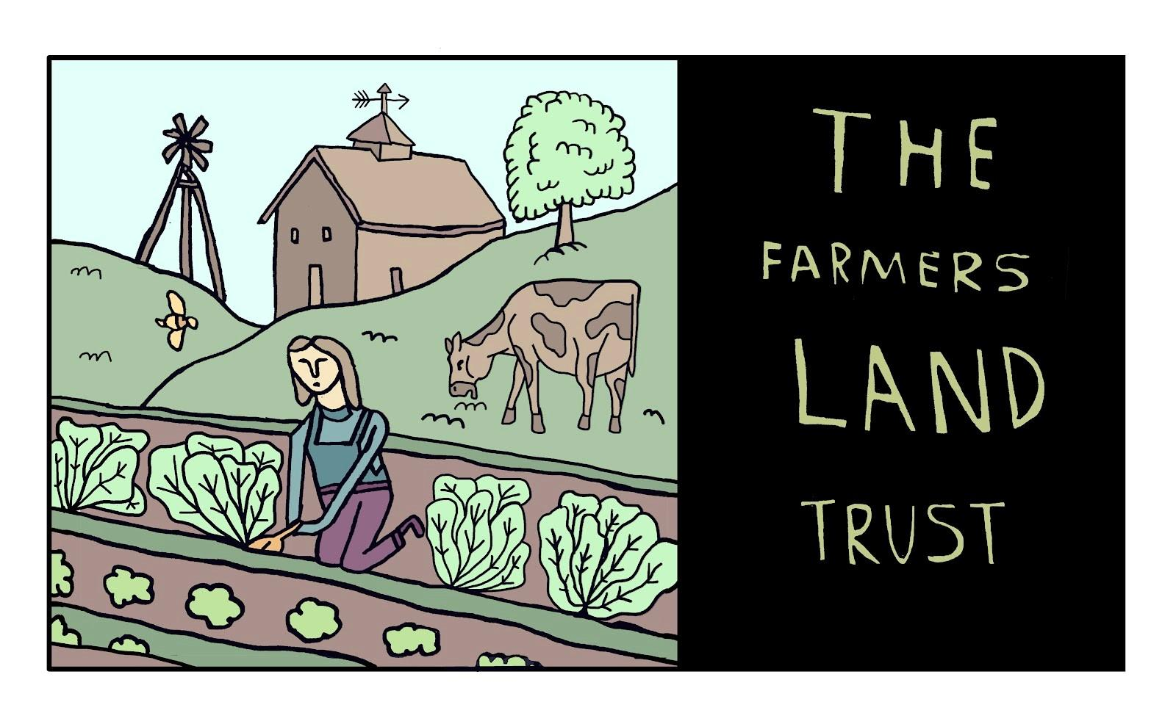
EMPLOYMENT JOB APPLICATION
PERSONAL INFORMATION
FULL NAME: ____________________________________ DATE: ________
First Middle Last
ADDRESS: _______________________________________________________
Street Address Apt/Suite
_____________________________________________________
City State Zip Code
E-MAIL: ____________________________ PHONE: _______________
SOCIAL SECURITY NUMBER (SSN): ___________________
DATE AVAILABLE:__________________
POSITION APPLIED FOR: _________________________
EMPLOYMENT DESIRED: ☐ FULL-TIME ☐ PART-TIME

EMPLOYMENT ELIGIBILITY
ARE YOU LEGALLY ELIGIBLE TO WORK IN THE U.S? ☐ YES ☐ NO
HAVE YOU EVER WORKED FOR THIS EMPLOYER? ☐ YES ☐ NO
*IF YES, WRITE THE START AND END DATES: ____________________________________
HAVE YOU EVER BEEN CONVICTED OF A FELONY? ☐ YES ☐ NO
*IF YES, PLEASE EXPLAIN: ____________________________________________________
EDUCATION

HIGH SCHOOL: __________________________ CITY / STATE: ____________
FROM:_____________________ TO: ___________________
GRADUATE? ☐ YES ☐ NO DIPLOMA: _____________________
COLLEGE: ___________________________ CITY / STATE: _____________
FROM: _____________________ TO: 1_____________________
GRADUATE? ☐ YES ☐ NO DEGREE: _____________________
GRADUATE: ________________ CITY / STATE: _________________

FROM: _____________________ TO: _____________________
DEGREE/CERTIFICATION: _____________________
OTHER: _____________ CITY / STATE: ___________
FROM: _____________________ TO: _____________________
DEGREE/CERTIFICATION: _____________________
PREVIOUS EMPLOYMENT
EMPLOYER 1: ____________________________________________
Company / Individual
MAY WE CONTACT THIS EMPLOYER? ☐ YES ☐ NO
EMPLOYER 2: _________________________________________
Company / Individual
MAY WE CONTACT THIS EMPLOYER? ☐ YES ☐ NO*
EMPLOYER 3: _____________________________________
Company / Individual
MAY WE CONTACT THIS EMPLOYER? ☐ YES ☐ NO
PROFESSIONAL REFERENCES
(PROFESSIONAL OR ACADEMIC ONLY)
FULL NAME: __________________________ RELATIONSHIP: ______________
First Last
COMPANY/SCHOOL: ____________ TITLE:
SUPERVISOR’S/ADVISOR’S/SIMILAR NAME AND TITLE:___________________________ E-MAIL: ______________ PHONE: _____________________
FULL NAME: ___________________________________ RELATIONSHIP: _______
First Last
COMPANY/SCHOOL: _________________________ TITLE: ___________________
E-MAIL: ___________________ PHONE: _______
FULL NAME: ________________________________ RELATIONSHIP: __________
First Last
COMPANY/SCHOOL: ____________________ TITLE: ___________________
E-MAIL: __________________________ PHONE: _______________

OTHER SKILLS
DETAILS: _________________
______________________________________________________________________
______________________________________________________________________
BACKGROUND CHECK CONSENT
IF ASKED, ARE YOU WILLING TO CONSENT TO A BACKGROUND CHECK? ☐ YES ☐ NO
DISCLAIMER
Applicant understands that The Farmers Land Trust is an equal opportunity employer. All applicants will be considered for employment without attention to race, color, national origin, religion or religious creed, sex, sexual orientation, gender, gender identity or expression, HIV or other medical condition, pregnancy or childbirth, national origin, veteran or disability status, genetic information, age (40 or older), military or veteran status or exigencies, marital status, reproductive health decision-making, or any other class protected by law. The Farmers Land Trust is committed to excellence through diversity. .
Incomplete or illegible applications will not be considered.
I, the Applicant, certify that my answers are true and honest to the best of my knowledge. If this application leads to my eventual employment, I understand that any false or misleading information in my application or interview may result in my employment being terminated.
SIGNATURE _________________________________ DATE ________
PRINT NAME _________________________________

